

WEB TECHNOLOGIES 1: UE18CS204

PROJECT NAME: 1 PES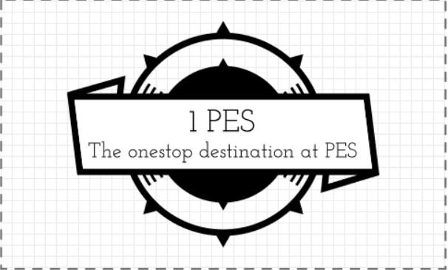



TEAM MEMBERS:

1.NAME: SAI EASHWAR KS

SRN: PES1201801910

2.NAME: SRINATH MP

SRN: PES1201801946

3.NAME: SWAROOP BS

SRN: PES1201801559

**DESCRIPTION:** A one stop site for all student problems in the campus. The first problem we want to tackle is the overcrowding in the campus canteens. Overcrowding causes so much waste of time and it is a very unpleasant experience to the students. So we enable students to book the food they want prior to the lunch break and this information is made available to the canteen management so that they can be prepared before lunch break and the students can come and collect their food without having to wait in crowd. In the future we look forward to tackle many such problems (like enabling the students to know if a particular book is available in the library and/or when it will be available next without having to go till the library). Software used - HTML, CSS, Bootstrap, jQuery, JavaScript, AJAX

UI: Front end UI will be built using HTML and CSS ( using both CSS developed by us, and also using bootstrap templates and classes).The web app also contains the frequently ordered items to enable faster ordering. There will be 8-10 pages. They include basic ones like Home, Login, Feedback etc. There will be as many other pages as there are the number of canteens, the students can book food from any one of them and if the orders for any item exceed a particular limit, the item will not be available to order .The availability of food will be monitored by the management , once a dish goes out of stock it will not be subjected to ordering .There will be separate login for canteen management and administrators and students, through which they can carry out functionalities such as ,deciding the menu, ordering food, checking availability of books.

There will be another page where we will provide interesting stats like "the most bought food of the day" etc. If time permits, we'll try to tackle the library issue or else we look forward to implement it after the semester ends. Towards the end of this conjuncture, the site will stand for its tagline ‘ ***The one stop destination at PES***’ , with application ranging from food ordering , book renting from library and checking availability, mutual books and resource sharing platform, booking of basketball and football courts and seminar halls by both students and faculty. Considering the time constraint the site will be projected to host real time events happening through out the campus. Therefore every event happening in the campus ranging from seminars to symposiums ,along with their venue will be made available in the 1 PES site making it truly the one stop destination.

USER VIEW

CANTEEN MANAGEMENT